Manual for hosting the asp.net website

The asp.net website can be run using a server either on the same pc, or another pc on the local network, in both cases you have to update the web.config file in the visual basic project called WebGUI, in the tag called client:

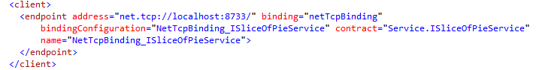

The address must be set to the ip on which the server is running, in this case its running on the same machine.

Running the application outside visual studio

If you don’t want to run the asp.net website inside visual studio you can easily follow the next steps to run it with IIS.

When that is in order, you have to add the project WebGUI into “C:\inetpub\wwwroot ”(assuming IIS is installed), then you have to open IIS and right click “Default Web Site” and choose “add application” then choose the folder called WebGUI you just put into “inetpub/wwwroot”, make sure the AppPool is set to .Net 4.0, and the application set to run as x86 mode, finally you can press the “browse project \*.80(http)” on the right in the IIS interface. It should then open the application in the browser and you can now add projects and get started.